Peerless Wholesale Vending
Appendix

Peerless Wholesale, Inc.

Income Statement
For the Year Ended December 31, 20xx
(Rounded to nearest thousand)

 |  |  | Financial  Statement |  | Tax  Return
Sales Revenue |  |  | $26,000,000 |  | $26,000,000
Cost of Goods Sold:
 | Beginning Inventory |  | 4,000,000 |  | 4,000,000
 | Purchases |  | 17,885,000 |  | 17,885,000
 | Cost of Goods Available |  | 21,885,000 |  | 21,885,000
 | Ending Inventory |  | 3,350,000 |  | 3,350,000
Cost of Sales |  |  | 18,535,000 |  | 18,535,000
Expenses:
 | Depreciation |  | 909,000 |  | 909,000
 | Officers’ Compensation
 |  | Salaries | 250,000 |  | 250,000
 |  | Cash Bonuses | 100,000 |  | 100,000
 | Selling, General, and Administrative Expenses |  | 2,250,000 |  | 2,250,000
Total Expenses |  |  | 22,044,000 |  | 22,044,000
Income Before Taxes |  |  | 3,956,000 |  | $ 3,956,000
Income Tax Expense |  |  | 1,532,000
Net Income |  |  | $ 2,424,000
Earnings/Share |  |  | $2.42

Computation of Income Tax Expense
 | Income before Taxes | $ 3,956,000 |  | $ 3,956,000
 | Income Tax @ 40% | 1,582,000 |  | 1,582,000
 | Less: ITC | 50,000 |  | 500,000
 | Income Tax Expense | 1,532,000
 | Income Tax Payable |  |  | 1,082,000
 | Deferred Income Tax Credit | 450,000

Peerless Wholesale, Inc.

Balance Sheet
December 31, 20xx
(Rounded to nearest thousand)

Assets | January 1 |  | December 31
Current Assets:
Cash | $ 5,122,000 |  | $ 7,515,000
Accounts Receivable | 3,106,000 |  | 4,312,000
Inventories | 4,000,000 |  | 3,350,000
Total Current Assets | 12,228,000 |  | 15,177,000
Fixed Assets | 5,000,000 |  | 5,000,000
Less Accumulated Depreciation | 1,000,000 |  | 1,909,000
Net Fixed Assets | 4,000,000 |  | 3,091,000
Total Assets | $16,228,000 |  | $20,268,000

Liabilities and Equity
Liabilities
Current Liabilities | $ 4,000,000 |  | $ 3,282,000
Long-term Liabilities | 0 |  | 2,006,000
Deferred Income Tax Credit | 0 |  | 450,000
Total Liabilities | 4,000,000 |  | 5,732,000
Shareholder’s Equity:
Common Stock | 10,000,000 |  | 10,000,000
Retained Earnings | 2,106,000 |  | 4,530,000
Total Equity | 12,106,000 |  | 14,530,000
Total Liabilities & Equity | $16,106,000 |  | $20,268,000

Peerless Wholesale, Inc.

Inventory Record

Field  Name | Data  Name | Picture | Edit  Requirements
Product Number | PR-NUMBER | X(08) | Numeric
Product Description | PR-DESCRIPTION | X(30) | None
Product Vendor | PR-VENDOR-NUMBER | X(08) | Numeric; Valid number in Vendor File
Average Cost | PR-AVG-COST | 9(06)V99 | Calculated
Unit of Sale/Purchase | PR-UNIT-OF-SALE | 9(03) | Numeric
Quantity on Hand | PR-QUANT-ON-HAND | 9(06) | Numeric
Quantity on Order | PR-QUANT-ON-ORDER | 9(06) | Numeric
Reorder Quantity | PR-REORDER-QUANT | 9(06) | Numeric
Minimum Order Quantity | PR-MIN-ORDER-QUANT | 9(06) | Numeric
Selling Price per Unit | PR-UNIT-SELL-PRICE | 9(06)V99 | Numeric
Year-to-Date Sales in Units | PR-YTD-UNIT-SALES | 9(07) | Numeric
Year-to-Date Sales in Dollars | PR-YTD-DOLLAR-SALES | 9(07)V99 | Numeric
Month-to-Date Sales in Units | PR-MTD-UNIT-SALES | 9(07) | Numeric
Month-to-Date Sales in Dollars | PR-MTD-DOLLAR-SALES | 9(07)V99 | Numeric
Last Purchase Order Number | PR-LAST-PO-NUMBER | X(08) | Numeric; Valid P.P. number in Purchasing File
Warehouse Aisle Number | PR-WRHSE-AISLE-NUMBER | X(03) | Range: 101 – 215: Lookup in Aisle Number File
Warehouse Bin Number | PR-WRHSE-BIN-NUMBER | X(04) | Range: 1 – 28

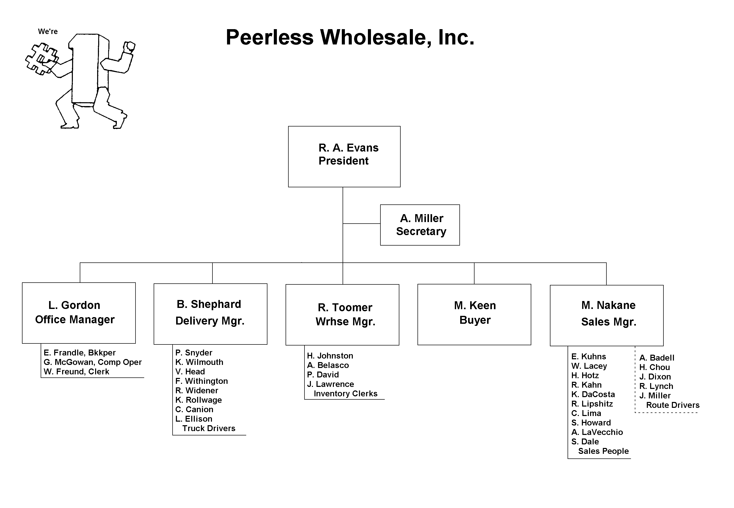
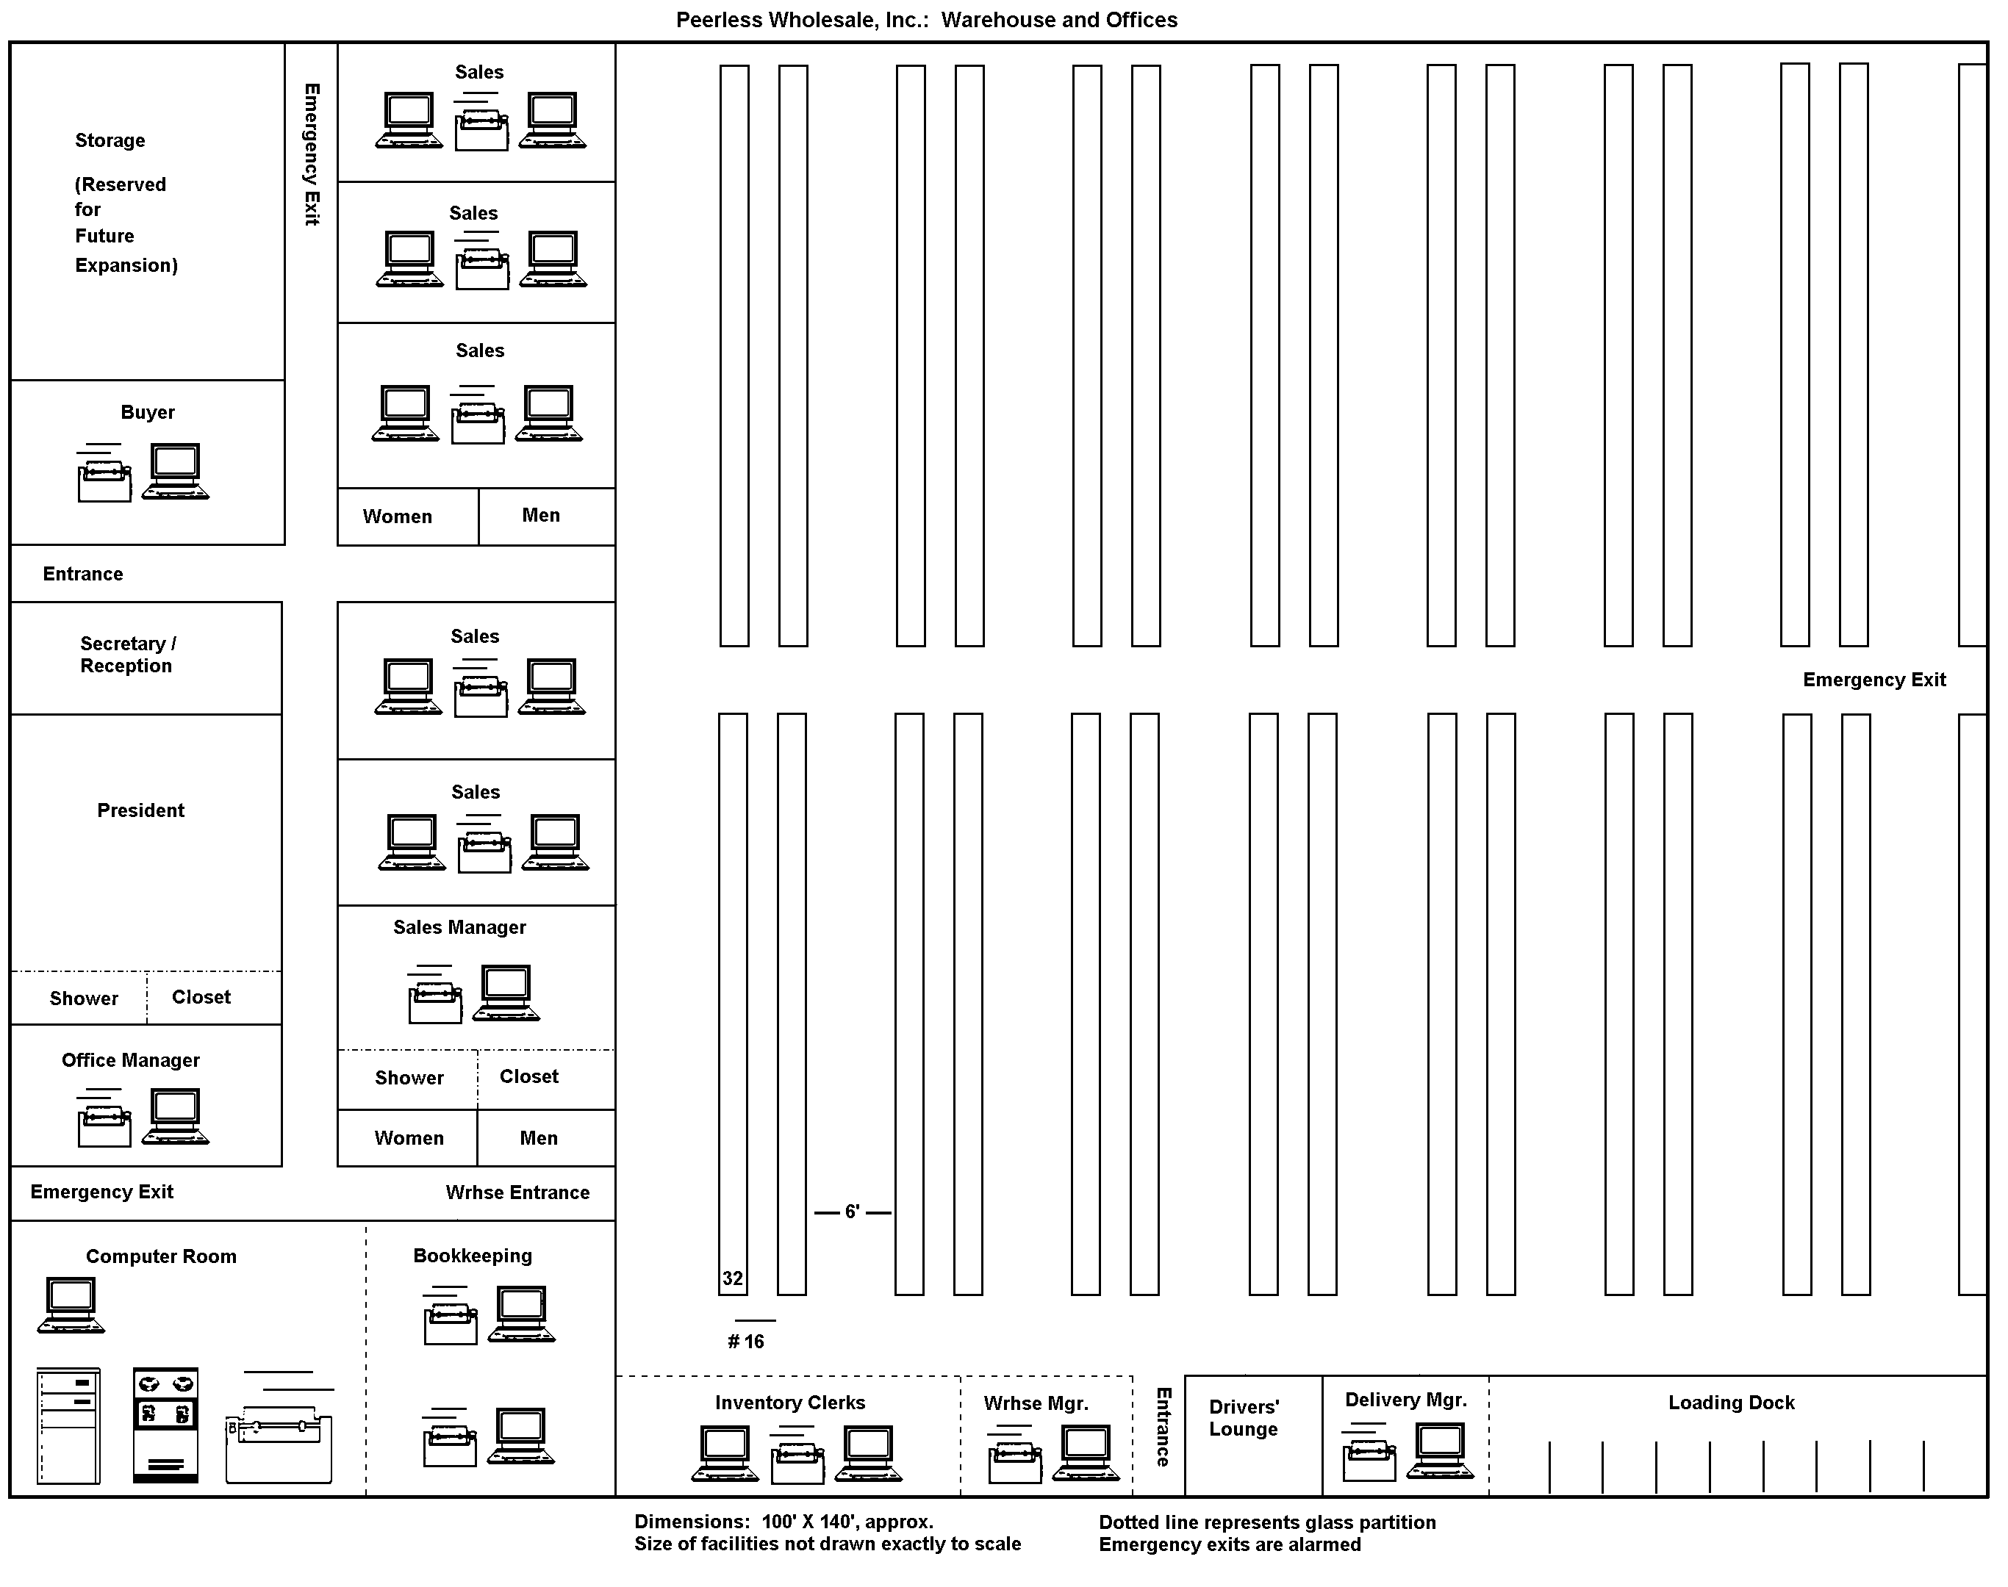Peerless Wholesale, Inc.: Warehouse and Offices
Peerless Wholesale, Inc.: Warehouse and Offices
